3. ReactJS-HOL

1) Successful Creation of the Score Calculator React Project

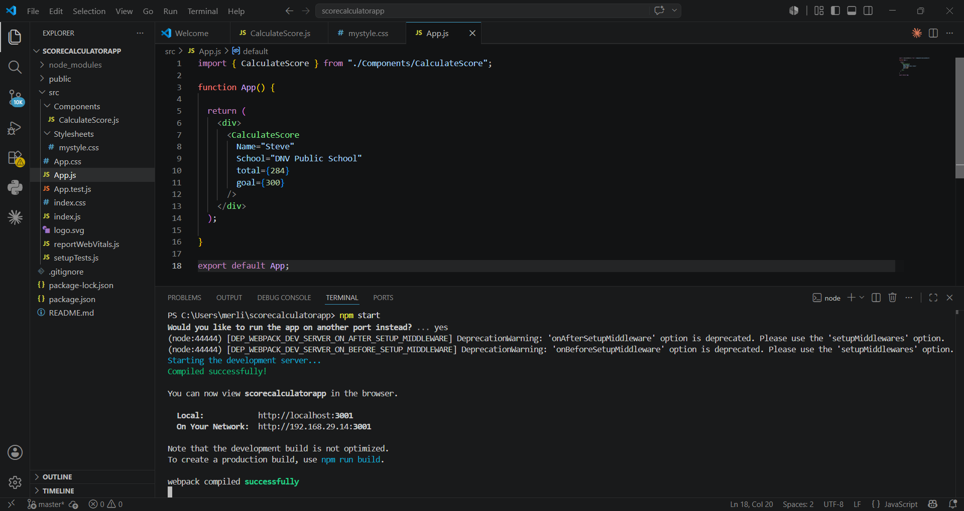2: Opening the Score Calculator Project in Visual Studio Code 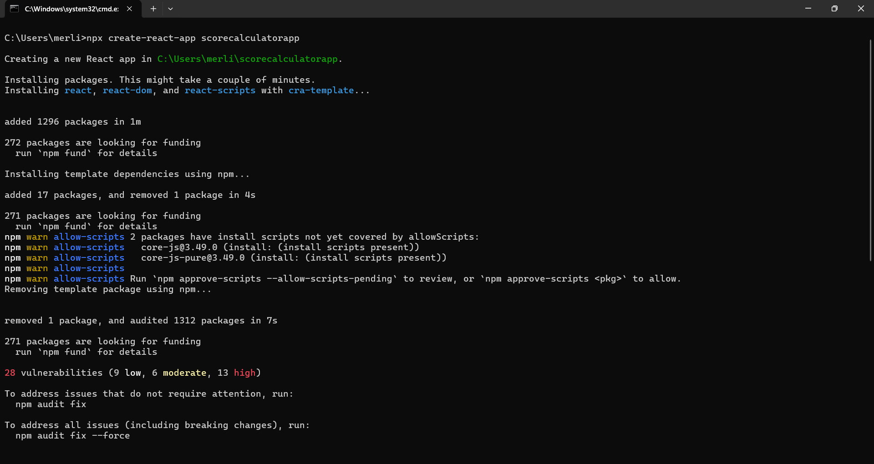

3: Successful Compilation and Execution of the Score Calculator Application
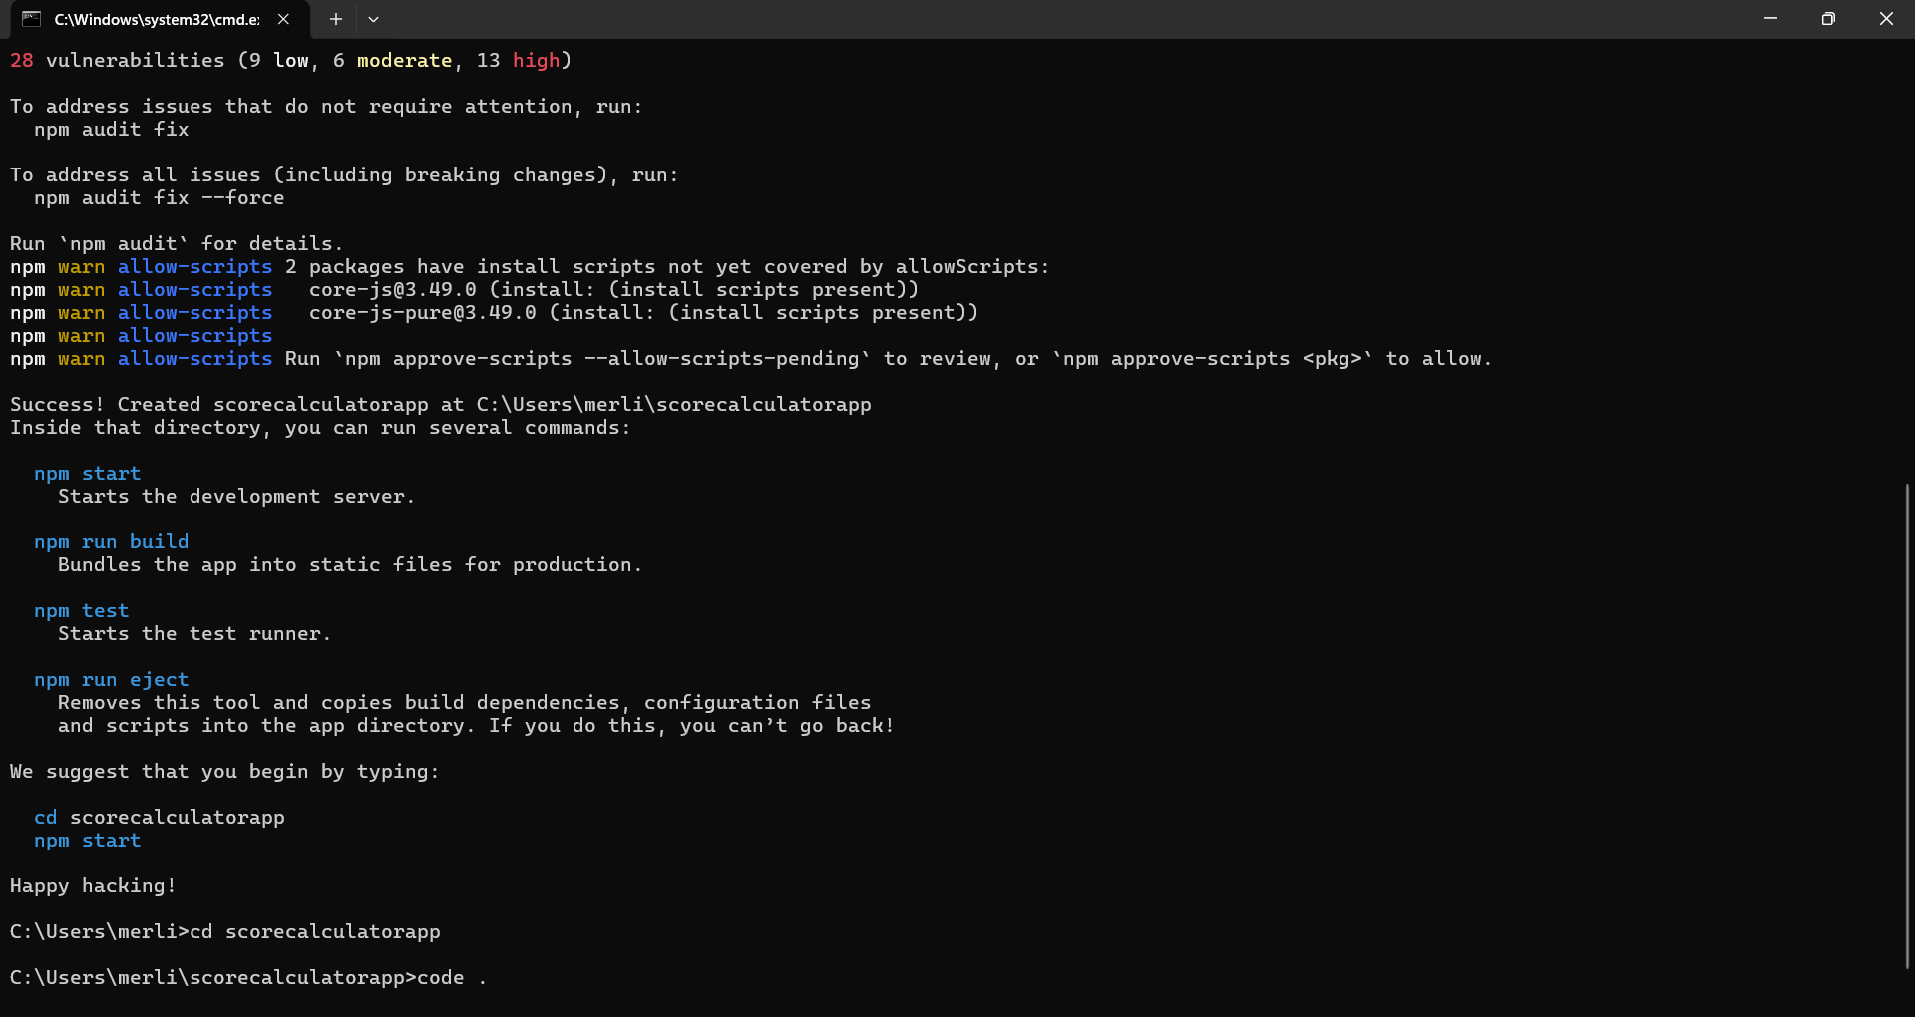4: Output of the Student Score Calculator Application
